

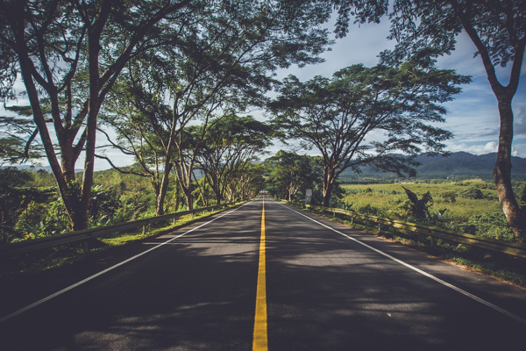

**Day 12: Returning Journey**

Travel: Jammu to Delhi | Distance: 600 km | Time: 12 hours   
Early morning departure for Delhi by bus. Enjoy light snacks and games en route, reminiscing about the past days. Arrive in Delhi by evening and check into a hotel. Free time for rest, preparing for a long train journey ahead.  
  
---